Name: Y.J.HARIHARAN

Roll No: 224E1A4719
Course: Data Analytics with Tableau

Assignment: Assignment 1

Assignment 1: Data Analytics with Tableau

Title:

Supermarket Sales Data Visualization and Analysis

Introduction:

This assignment focuses on analyzing supermarket sales data collected from three branches over a period of three months. Using Tableau, various visualizations were created to understand sales trends, customer distribution, and product performance. The insights from this analysis can help the supermarket improve decision-making, marketing strategies, and customer experience.

Visualizations:
- Bar Chart: Total Sales by Product Line
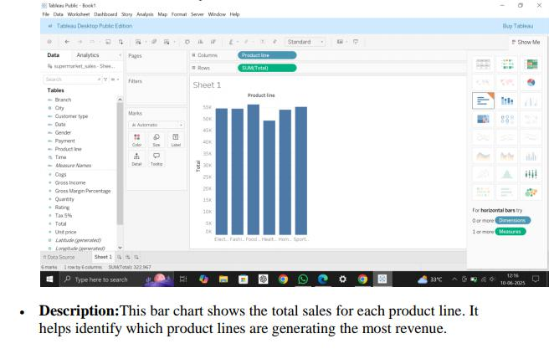

- Pie Chart: Payment Method Distribution
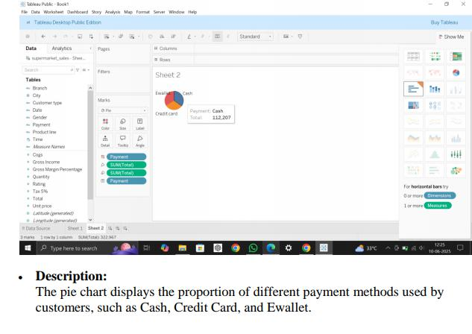

- Stacked Bar Chart: Total Sales by city and Gender
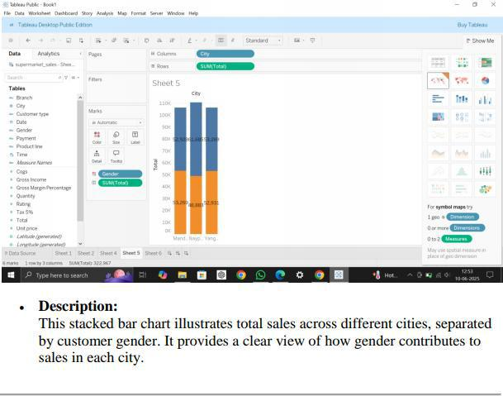

- Line Chart: Daily Sales Trend
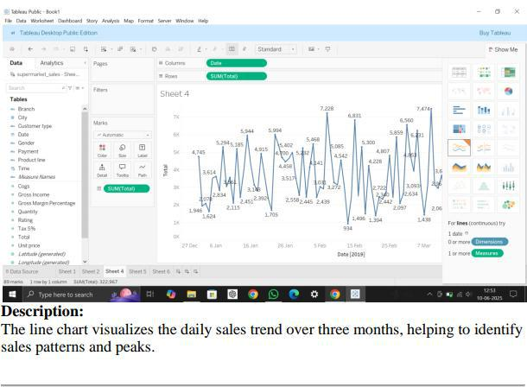

5. Bubble Chart: Quantity vs Gross Income by Product Line
